Week 2 – Assignment
Marco Garcia
The University of Arizona Global Campus
CST499 : Capstone for Computer Software Technology
Professor: Charmelia Butler
August 17, 2026

Introduction
Software requirements describe what a system is expected to accomplish, while software design provides a clearer picture of how those requirements can be organized and implemented. The Online Course Enrollment System developed in Week 1 requires students to register, log in, view available courses, enroll in course sections, join waitlists when sections are full, cancel enrollments, and receive notifications. The system must also maintain information about users, courses, semesters, enrollment limits, and waitlists. Unified Modeling Language models provide different ways to represent these requirements before the system is fully developed. According to Tsui et al. (2018), software design helps transform requirements into a structure that developers can use during implementation. The purpose of this paper is to present the UML design models for the Online Course Enrollment System and explain how component, integration, system, and acceptance testing can be used to verify that the completed system meets its requirements.
UML Design Models
The UML models provide both static and dynamic views of the Online Course Enrollment System. Each model focuses on a different part of the design so that the system can be understood from several perspectives. The use case diagram provides a broad view of how students, advisors, instructors, and administrators interact with the system. Important student functions include searching for courses, viewing course information, enrolling, dropping a course, viewing current enrollments, and joining a waitlist. The model also identifies functions performed by other users, such as managing course sections, approving enrollments, and managing users.
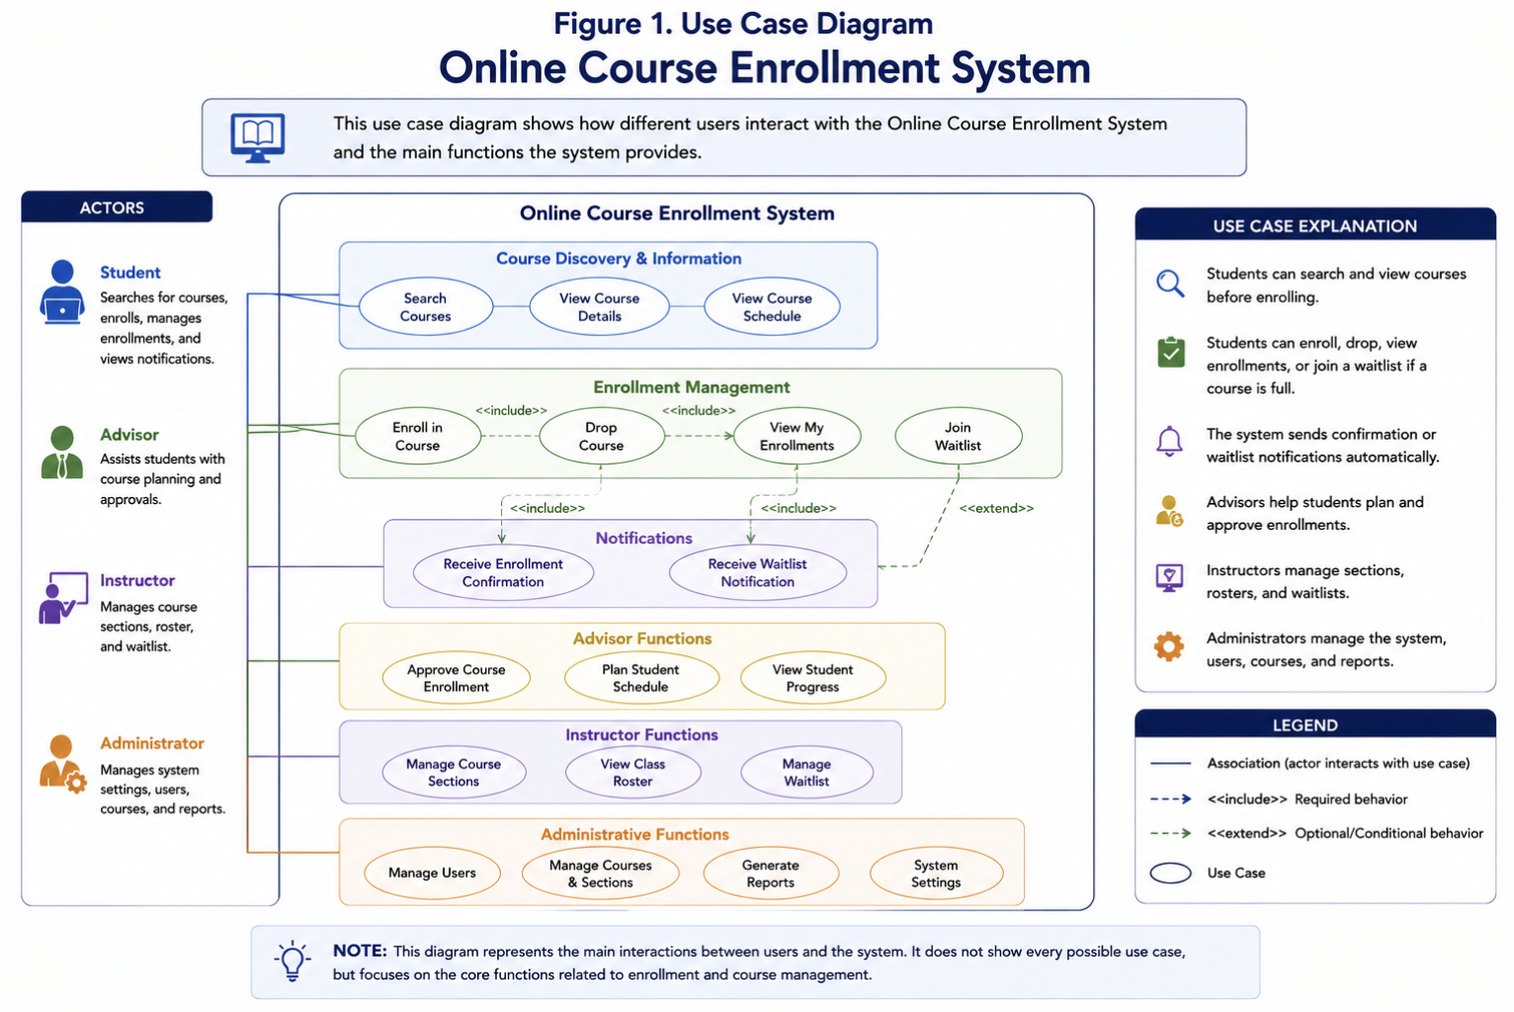Figure 1: Use Case Diagram for the Online Course Enrollment System
The class diagram provides the main static view of the design. It identifies important classes such as User, Student, Advisor, Instructor, Administrator, Course, Section, Enrollment, Waitlist, Notification, and SystemSetting. It also shows how these classes are connected. For example, a course can contain multiple sections, while students can have enrollment records associated with course sections. The class diagram helps establish how information can be organized within the system.
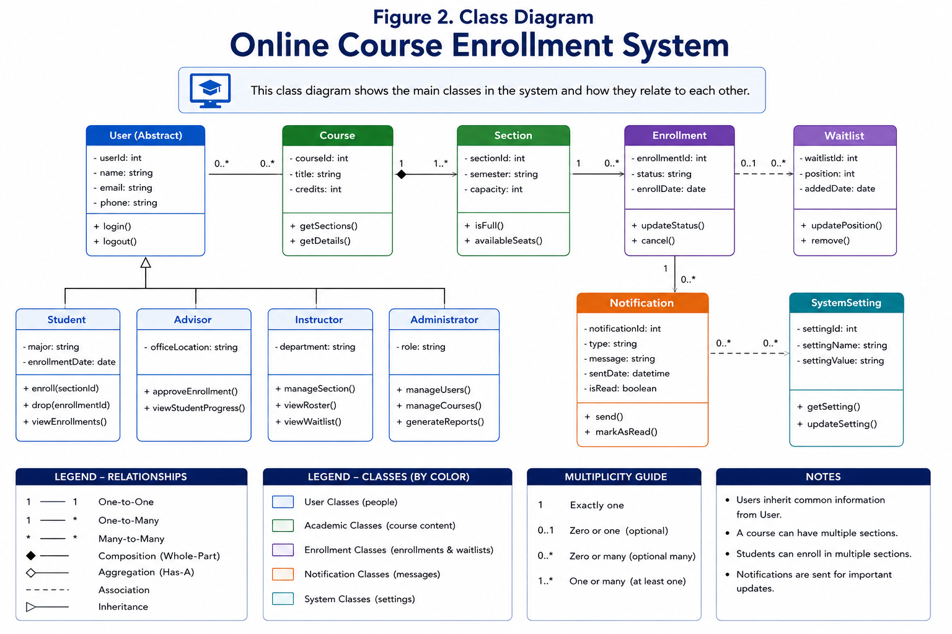Figure 2: Class Diagram for the Online Course Enrollment System
The remaining UML models focus more closely on system behavior. The sequence diagram follows the order of interactions that occur when a student enrolls in a course. The system checks whether seats are available and either creates the enrollment or places the student on the waitlist. Sequence diagrams are useful because they represent interactions in the order in which they occur, which can also support the creation of test cases (Baker et al., 2008).
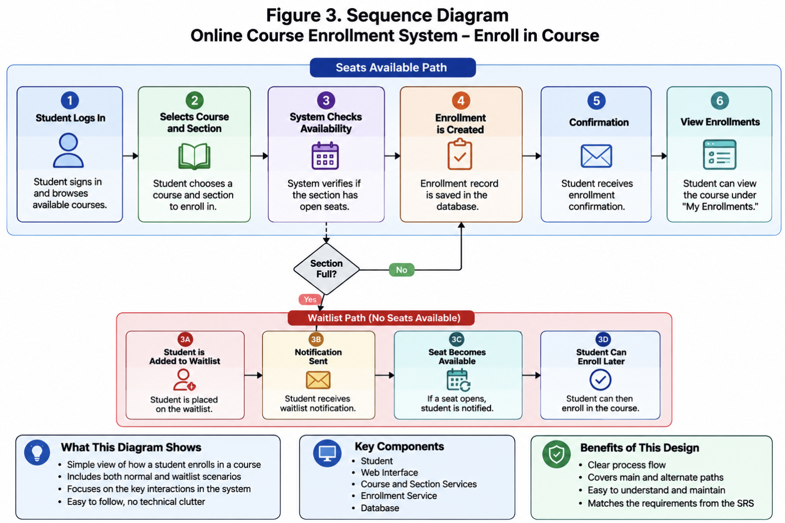Figure 3: Sequence Diagram for Course Enrollment
The activity diagram presents the enrollment process as a flow of actions and decisions. It shows the student selecting a course, the system checking seat availability, the database saving enrollment information, and the system sending a confirmation. It also shows the alternate path that occurs when a section is full.
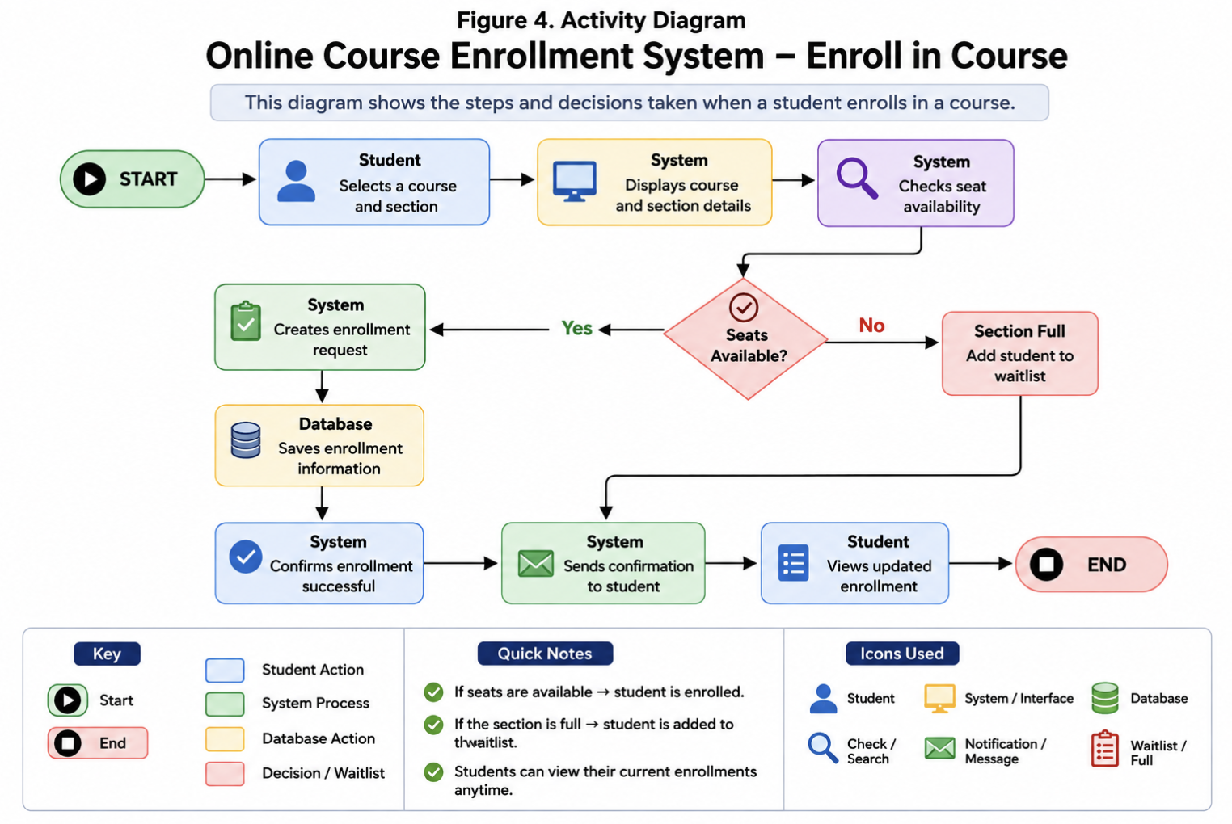Figure 4: Activity Diagram for Course Enrollment
Finally, the state diagram shows how an enrollment can move through different conditions. A student may become enrolled immediately, enter a waitlist, remain on the waitlist, or move from the waitlist into an enrolled state when a seat becomes available. Activity and state models can be particularly useful when designing tests because they represent system behavior and the different paths that should be examined during testing (Felderer & Herrmann, 2019).
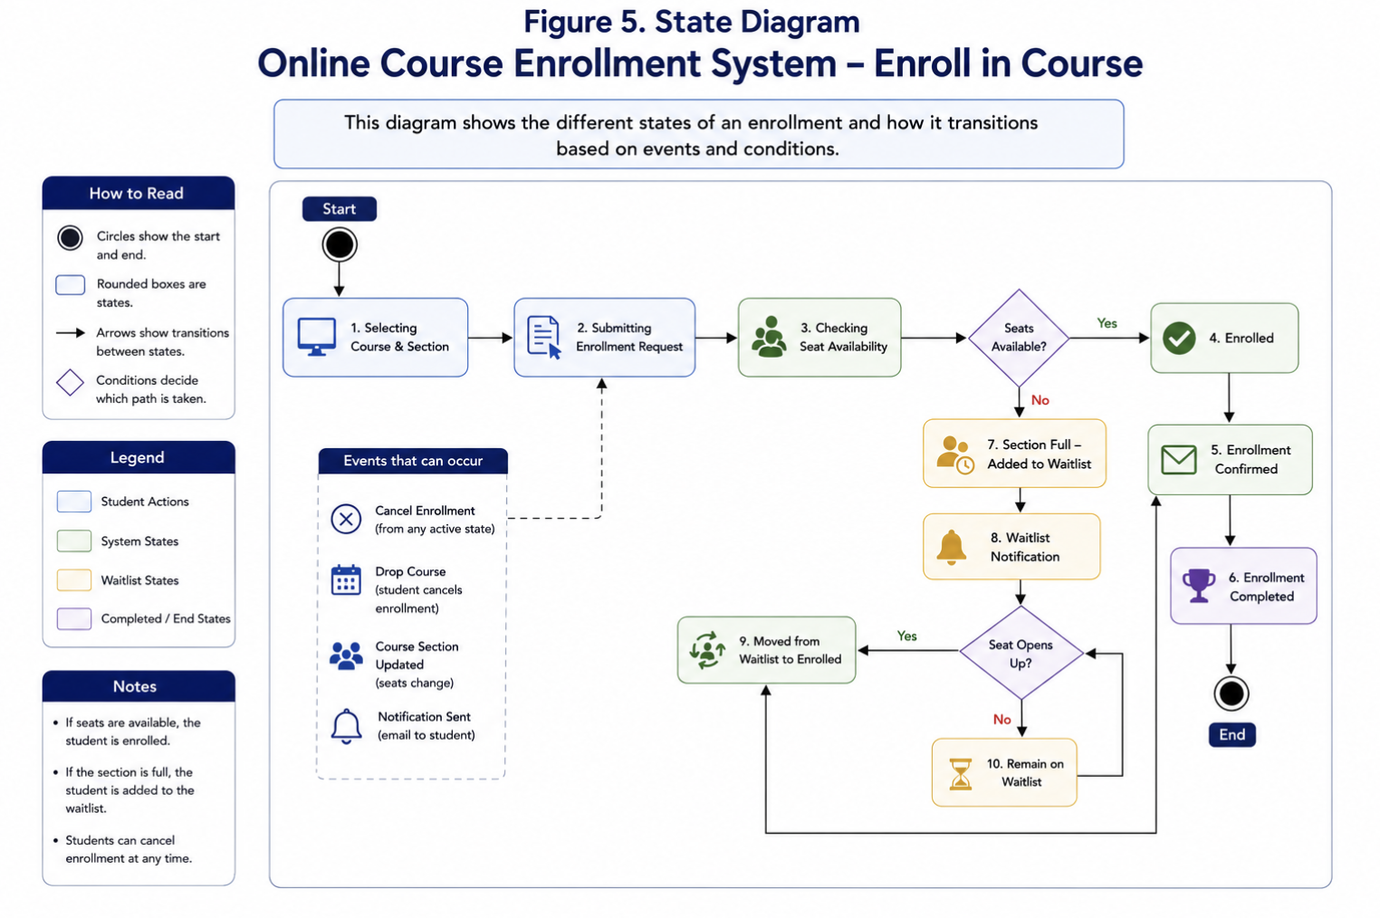Figure 5: State Diagram for Course Enrollment
Component Testing
Component testing focuses on individual parts of the software before determining whether the entire system works correctly. Tsui et al. (2018) explain that testing individual software units helps identify problems before those units become part of a larger system. For the Online Course Enrollment System, individual components could include user login, course searching, enrollment processing, waitlist management, and notifications.
For example, the enrollment component could be tested to determine whether it correctly creates an enrollment when a course has available seats. The waitlist component could separately be tested to verify that a student is added when the section reaches its enrollment limit. Notification functions could also be tested to make sure the appropriate message is created after an enrollment or waitlist change. Testing these smaller pieces individually makes it easier to locate the cause of a problem.
Integration Testing
Integration testing takes place after individual components have been tested and begins examining whether they work correctly together. This is especially important for the proposed system because many functions depend on information being passed between different components. The sequence and activity diagrams demonstrate several of these connections.
For example, when a student selects a course, the enrollment process must communicate with the course section information to determine whether a seat is available. If space exists, the enrollment information must be saved and a confirmation must be sent. If the section is full, the waitlist function must receive the correct student and course information instead. Integration testing would verify that information moves correctly between these parts of the system. This level of testing can identify problems that might not appear when each component is tested separately.
System Testing
System testing evaluates the complete application as one system. At this point, the goal is to determine whether the complete Online Course Enrollment System behaves according to the requirements established in the SRS. Model based testing can use representations of expected system behavior to help develop test cases and determine whether the implemented system conforms to its requirements (Baker et al., 2008).
Testing should include complete scenarios rather than only individual functions. One scenario could begin with a student logging in, viewing courses for a semester, selecting a section with available seats, completing enrollment, receiving confirmation, and viewing the updated enrollment. Another scenario should test a full section to confirm that the student is placed on the waitlist and receives the correct notification. The system should also be tested when students cancel enrollments because an available seat may cause another student to move from the waitlist. These scenarios closely follow the activity, sequence, and state diagrams and help confirm that the completed system follows the intended design.
Acceptance Testing
Acceptance testing is the final level discussed for this system and focuses on determining whether the software satisfies the needs of its intended users. Instead of concentrating mainly on individual technical components, acceptance testing considers whether users can successfully perform the activities identified in the requirements.
For the Online Course Enrollment System, students should be able to register, log in, locate courses, enroll in available sections, join waitlists, cancel enrollments, and receive appropriate notifications. Other system users should also be able to complete the functions associated with their roles. For example, administrators should be able to manage users and courses, while instructors should be able to view class information. Successful acceptance testing would provide evidence that the system does what the SRS requires and is ready for its intended users.
Conclusion
UML modeling provides a useful connection between the requirements of the Online Course Enrollment System and its eventual implementation. The use case and class diagrams identify the users, functions, and structural elements of the system, while the sequence, activity, and state diagrams demonstrate how important processes behave. These models can also support testing because they identify the components, interactions, decisions, and expected outcomes that should be verified. Component testing examines individual functions, integration testing verifies communication between those functions, system testing evaluates the complete application, and acceptance testing determines whether the finished system meets user requirements. Together, the UML models and testing levels provide a structured approach for moving the Online Course Enrollment System from its SRS requirements toward a complete and reliable software application.

References

Baker, P., Dai, Z. R., Grabowski, J., Haugen, Ø., Schieferdecker, I., & Williams, C. (2008). Model driven testing: Using the UML testing profile. Springer. https://doi.org/10.1007/978-3-540-72563-3
Felderer, M., & Herrmann, A. (2019). Comprehensibility of system models during test design: A controlled experiment comparing UML activity diagrams and state machines. Software Quality Journal, 27, 125–147. https://doi.org/10.1007/s11219-018-9407-9
Tsui, F., Karam, O., & Bernal, B. (2018). Essentials of software engineering (4th ed.). Jones & Bartlett Learning.

